Default Report
Human Rights Survey: Internships
April 18th 2022, 12:20 pm MDT
QID1 - Please mark your grade level
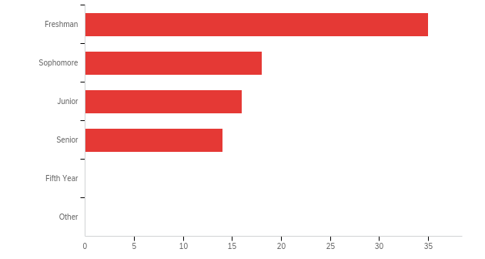

# | Field | Minimum | Maximum | Mean | Std Deviation | Variance | Count
1 | Please mark your grade level - Selected Choice | 1.00 | 4.00 | 2.11 | 1.13 | 1.28 | 83

# | Answer | % | Count
1 | Freshman | 42.17% | 35
2 | Sophomore | 21.69% | 18
3 | Junior | 19.28% | 16
4 | Senior | 16.87% | 14
5 | Fifth Year | 0.00% | 0
6 | Other | 0.00% | 0
 | Total | 100% | 83

QID1_6_TEXT - Other
Other - Text

Q4 - What is your major(s)?

Major #1 | Major #2
economy
International Relations
Anthropology
Sociology
Biochemistry and molecular biology
sociology
Undeclared
Political Science
NA
Materials science and engineering
Biological sciences
ETOX
undecided
Human Development
Biotechnology
Design
Design
Statistics
Plant Biology
Biological science
Computer Engineering
Biological Sciences
Neurobiology
Bio sci
undeclared
Political Science
Psychology
Neurobiology, Physiology, and Behavior
Environmental Science and Management
undeclared
Electrical Engineering
political science
Psychology
Psychology
Political Science - Public Service
Managerial Economics
Communication
Political Science
Environmental Policy Analysis and Planning
Chemistry
History
Asian American cultural studies
International Relations | French
Psychology
Political Science
Political Science
Biological Sciences
Sociology Law & Society
Psychology
Political Science
psychology
psychology
Psychology | Gender, Sexuality and Women's studies
Psychology
Sociology
GSW
Sociology
English
political science
Political Science
Gender, Sexuality, and Women's Studies
Environmental Policy Analysis and Planning
English
Sociology
Wildlife Conservation Biology
Global Disease Biology
Political Science
Biological Sciences
Economics
political science
Biotechnology
History | International Relations
International relations
IR
Sociology
Political Science - Public Service | English
International Relations | Spanish
International Relations
Political Science- Public Service | Economics
Political science
International Relations
Sociology

Q2 - Are you minoring in Human Rights Studies?
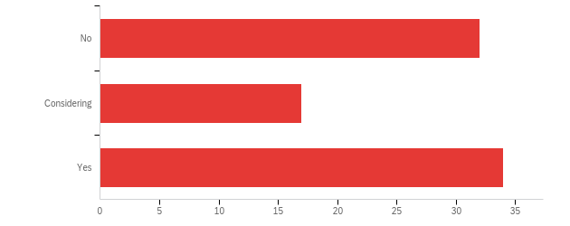

# | Field | Minimum | Maximum | Mean | Std Deviation | Variance | Count
1 | Are you minoring in Human Rights Studies? | 1.00 | 3.00 | 2.02 | 0.89 | 0.79 | 83

# | Answer | % | Count
1 | No | 38.55% | 32
2 | Considering | 20.48% | 17
3 | Yes | 40.96% | 34
 | Total | 100% | 83

Q30 - If a Human Rights Studies major were available, would you choose it?
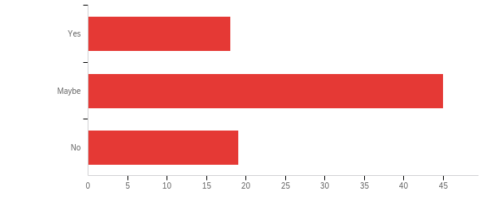

# | Field | Minimum | Maximum | Mean | Std Deviation | Variance | Count
1 | If a Human Rights Studies major were available, would you choose it? | 1.00 | 3.00 | 2.01 | 0.67 | 0.45 | 82

# | Answer | % | Count
1 | Yes | 21.95% | 18
2 | Maybe | 54.88% | 45
3 | No | 23.17% | 19
 | Total | 100% | 82

Q31 - If an internship was a major requirement, would you still choose to declare Human Rights Studies as your major?

# | Field | Minimum | Maximum | Mean | Std Deviation | Variance | Count
1 | If an internship was a major requirement, would you still choose to declare Human Rights Studies as your major? | 0.00 | 0.00 | 0.00 | 0.00 | 0.00 | 0

# | Answer | % | Count
1 | Yes | 0.00% | 0
2 | Maybe | 0.00% | 0
3 | No | 0.00% | 0
 | Total |  | 0

Q5 - Preliminary Career Field
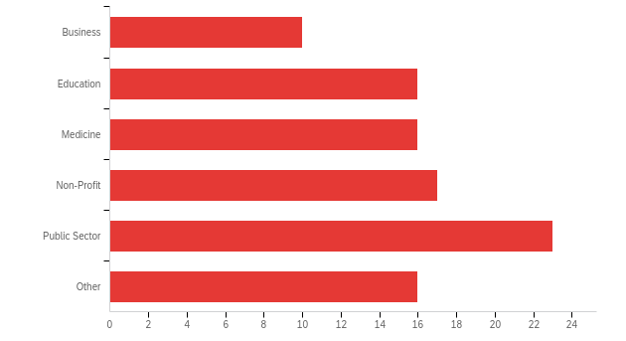

# | Answer | % | Count
1 | Business | 10.20% | 10
2 | Education | 16.33% | 16
3 | Medicine | 16.33% | 16
4 | Non-Profit | 17.35% | 17
5 | Public Sector | 23.47% | 23
6 | Other | 16.33% | 16
 | Total | 100% | 98

Q5_6_TEXT - Other
Other - Text
museums
Travel
Lab Technician
mental health services
stem
engineering
Social Sciences
Professor
Law
therapy
mental health care
Law
Life Sciences
Law??

Q6 - Please briefly describe any past internship you have held.

Please briefly describe any past internship you have held.
physical labor for my dad's wine business
N/A
I interned at the Rosicrucian Egyptian Museum in San Jose, California last summer (2021). I worked 9 hours shifts selling tickets at the door, designing and holding workshops for children, and giving guided tours of the museum's full-size replica tomb.
N/A
N/A
None
I was an intern at the youth education center on my reservation. I was a tutor/youth coordinator.
Intern at an elementary specifically in the science department. I thought kids some science and assisted them in their assignments.
N/A
I currently have an internship at an elementary school where I help the teacher with grading, students behaviors, and doing lessons.
None
I work at KDVS as a radio DJ and am currently training to become the community coordinator. I also work as a student assistant at the Tomato Genetic Research Center.
No past internships.
None
none
I have not taken any internships.
Soil science research lab
none
I had an internship at the senior center by my house. I helped run the technology support program for the seniors
None
I have had some online internships with companies outside of the States, in which we gathered studies and information about a specific topic.
Intern at a non-profit organization providing scholarships for Muslim students in underrepresented fields (Islamic Scholarship Fund), intern at a non-profit organization built on fighting implicit biases after a hate crime targeted toward Muslim people (Our Three Winners), intern at UC Davis' Middle Eastern, North African, and South Asian Resource Center.
none
N/A
N/A
N/A
Clinical unpaid internship
I was required to participate in a 30-hour internship for one quarter to pass my EDU100 class. I decided to do 40 hours at that internship during Winter Quarter '22 so that I could earn my transcript notation. It was unpaid and I worked as a Teaching Assistant at a local charter high school and helped with 3D printing and coding-related classes. I actually decided to stay on for another quarter because I enjoy the internship so much, especially working with the students.
A government internship with a local politician when I was in highschool
n/a
I have had an internship in my Edu 81 class with 2nd graders, where I was able to help them with their schoolwork and really build connections with them.
I've had peer mentorship experience with first years as well as administrative and marketing positions in clubs and orgs on canvas
Immigration Law Firm Internship
Legal News Website Writer
I have not.
Education internships
N/A
I have never held an internship :(
None
I’ve had internships where I thought math, and a current internship with a non profit organization in their Human Resources department
Lab work
I have not held an internship before.
1) Researching migration policy, migration flows
2) Coordinating collaborations and marketing for an on campus organization
- District Attorney’s Office, San Joaquin County
- External Affairs Department and Constituent Affairs Department, Office of California Governor Gavin Newsom
International Rescue Comittee, Administration and Client Coordinator Intern.
Article 26 Backpack, Team Lead for Team Mochila.
A26 Backpack Internship
Research Internship under Dr. Joseph at UC Davis
KDVS Freeform Radio Internship
Article 26 Backpack, IRC, congressional,
A26 Backpack, communications work, UCD Immigration Law Clinic, research, Flip the West, phone banking.
I was given a stipend of 1100 for 4 weeks of work. I worked in a summer school

Q7 - How important do you believe an internship is to your future career and ability to compete for employment in your chosen field?
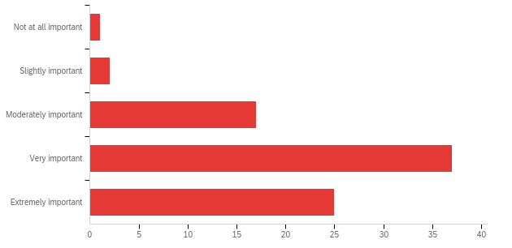

# | Field | Minimum | Maximum | Mean | Std Deviation | Variance | Count
1 | How important do you believe an internship is to your future career and ability to compete for employment in your chosen field? | 1.00 | 5.00 | 4.01 | 0.85 | 0.72 | 82

# | Answer | % | Count
1 | Not at all important | 1.22% | 1
2 | Slightly important | 2.44% | 2
3 | Moderately important | 20.73% | 17
4 | Very important | 45.12% | 37
5 | Extremely important | 30.49% | 25
 | Total | 100% | 82

Q8 - How important are financial considerations to you when deciding whether or not to take an internship or work?
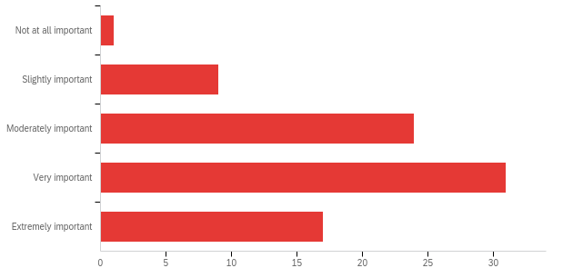

# | Field | Minimum | Maximum | Mean | Std Deviation | Variance | Count
1 | How important are financial considerations to you when deciding whether or not to take an internship or work? | 1.00 | 5.00 | 3.66 | 0.97 | 0.93 | 82

# | Answer | % | Count
1 | Not at all important | 1.22% | 1
2 | Slightly important | 10.98% | 9
3 | Moderately important | 29.27% | 24
4 | Very important | 37.80% | 31
5 | Extremely important | 20.73% | 17
 | Total | 100% | 82

Q9 - My family supports me taking internship opportunities?
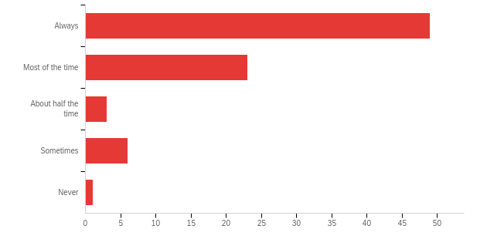

# | Field | Minimum | Maximum | Mean | Std Deviation | Variance | Count
1 | My family supports me taking internship opportunities? | 1.00 | 5.00 | 1.62 | 0.95 | 0.89 | 82

# | Answer | % | Count
1 | Always | 59.76% | 49
2 | Most of the time | 28.05% | 23
3 | About half the time | 3.66% | 3
4 | Sometimes | 7.32% | 6
5 | Never | 1.22% | 1
 | Total | 100% | 82

Q10 - My family would be able to provide me with financial support during an internship.
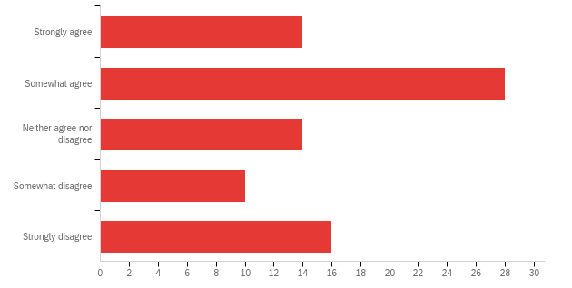

# | Field | Minimum | Maximum | Mean | Std Deviation | Variance | Count
1 | My family would be able to provide me with financial support during an internship. | 1.00 | 5.00 | 2.83 | 1.38 | 1.90 | 82

# | Answer | % | Count
1 | Strongly agree | 17.07% | 14
2 | Somewhat agree | 34.15% | 28
3 | Neither agree nor disagree | 17.07% | 14
4 | Somewhat disagree | 12.20% | 10
5 | Strongly disagree | 19.51% | 16
 | Total | 100% | 82

Q11 - My family would be able to provide me with housing support during an internship (including living at home).
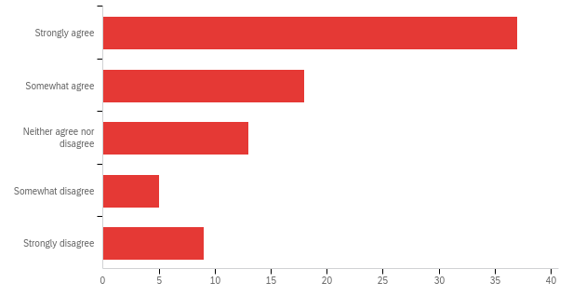

# | Field | Minimum | Maximum | Mean | Std Deviation | Variance | Count
1 | My family would be able to provide me with housing support during an internship (including living at home). | 1.00 | 5.00 | 2.16 | 1.35 | 1.82 | 82

# | Answer | % | Count
1 | Strongly agree | 45.12% | 37
2 | Somewhat agree | 21.95% | 18
3 | Neither agree nor disagree | 15.85% | 13
4 | Somewhat disagree | 6.10% | 5
5 | Strongly disagree | 10.98% | 9
 | Total | 100% | 82

Q12 - I have access to a car and insurance (or another form of consistent transportation).
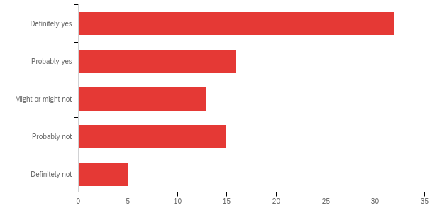

# | Field | Minimum | Maximum | Mean | Std Deviation | Variance | Count
1 | I have access to a car and insurance (or another form of consistent transportation). | 1.00 | 5.00 | 2.32 | 1.32 | 1.75 | 81

# | Answer | % | Count
1 | Definitely yes | 39.51% | 32
2 | Probably yes | 19.75% | 16
3 | Might or might not | 16.05% | 13
4 | Probably not | 18.52% | 15
5 | Definitely not | 6.17% | 5
 | Total | 100% | 81

Q13 - Have you ever turned down an internship opportunity for financial reasons?
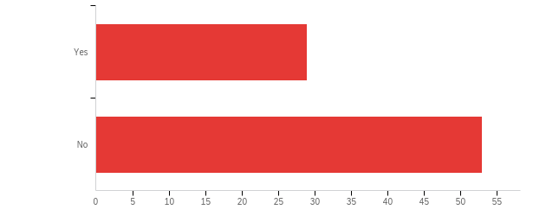

# | Field | Minimum | Maximum | Mean | Std Deviation | Variance | Count
1 | Have you ever turned down an internship opportunity for financial reasons? | 1.00 | 2.00 | 1.65 | 0.48 | 0.23 | 82

# | Answer | % | Count
1 | Yes | 35.37% | 29
2 | No | 64.63% | 53
 | Total | 100% | 82

Q14 - Please explain.

Please explain.
I was trying to get a investing bank internship, but the housing price at where the company located are too high, so I have to give it up.
Last year in January (2021), I got offered to intern for the avian barn but since my family and I were just getting over COVID I said I couldn't take it. Having COVID last year causes my parents to stop working and use whatever money they had to saved to get us through those two weeks as well as pay for the tests and medication.
I need to financially support myself with a paid job and do not have time to do an unpaid internship.
Couldn’t afford to not work
I live paycheck to paycheck there is just barely enough money for myself
Sometimes the demands for housing and things like that are way out of my budget and financial aid and so I have to turn them down.
As a low-income student participating in a internship that is unpaid is really difficult because I also would need to find on top of that.
Internships are work and should be paid
There was an internship I had to turn down because it was a big time commitment but it was not paid, I currently work full time so I was unable to take it because I needed to earn money
I am self funded
I have student loan payments and rent so I can’t afford to work for free
When given the chance between a paying job and an internship, I have chosen the job before.
I could not take other internships even if it sounded like a good opportunity
I received an internship offer, but was also offered paid work and I took the paid work experience despite the internship being more interesting to me for financial reasons.
Have turned down unpaid internships in the past.
I need to be able to pay my rent over the summer

Q17 - I would be able to take advantage of this opportunity without any additional support.
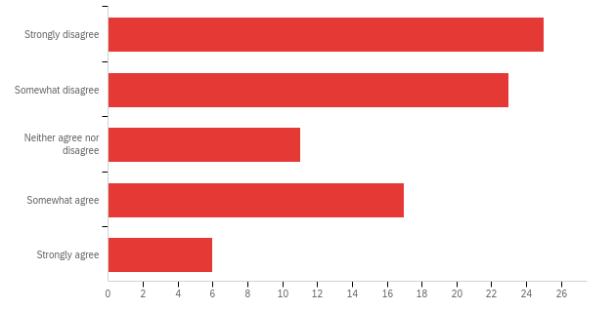

# | Field | Minimum | Maximum | Mean | Std Deviation | Variance | Count
1 | I would be able to take advantage of this opportunity without any additional support. | 1.00 | 5.00 | 2.46 | 1.31 | 1.71 | 82

# | Answer | % | Count
1 | Strongly disagree | 30.49% | 25
2 | Somewhat disagree | 28.05% | 23
3 | Neither agree nor disagree | 13.41% | 11
4 | Somewhat agree | 20.73% | 17
5 | Strongly agree | 7.32% | 6
 | Total | 100% | 82

Q18 - If you do not think you could take advantage of this opportunity, please indicate why:

# | Answer | % | Count
1 | I cannot afford to lose the income I would earn during that period. | 0.00% | 0
2 | I do not have access to housing if I am not an enrolled student. | 0.00% | 0
3 | I do not have an automobile or other reliable form of transportation. | 0.00% | 0
 | Total |  | 0

Q19 - If you received a stipend in support of the internship, what percentage of $6000 would be enough for you to choose it rather than work?
In answering this question, please assume that this would be in the form of a direct payment to you. Please check all that apply.
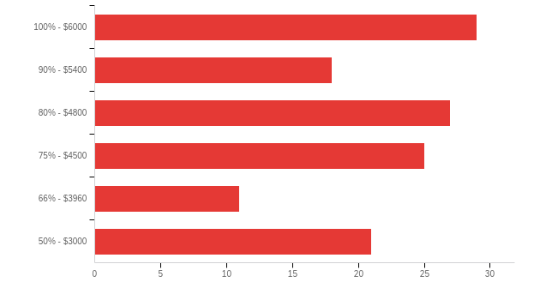

# | Answer | % | Count
1 | 100% - $6000 | 22.14% | 29
2 | 90% - $5400 | 13.74% | 18
3 | 80% - $4800 | 20.61% | 27
4 | 75% - $4500 | 19.08% | 25
5 | 66% - $3960 | 8.40% | 11
6 | 50% - $3000 | 16.03% | 21
 | Total | 100% | 131

Q22 - I would be able to take advantage of this opportunity without any additional support.
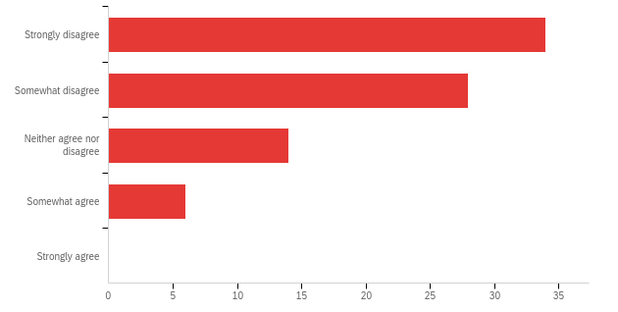

# | Field | Minimum | Maximum | Mean | Std Deviation | Variance | Count
1 | I would be able to take advantage of this opportunity without any additional support. | 1.00 | 4.00 | 1.90 | 0.93 | 0.87 | 82

# | Answer | % | Count
1 | Strongly disagree | 41.46% | 34
2 | Somewhat disagree | 34.15% | 28
3 | Neither agree nor disagree | 17.07% | 14
4 | Somewhat agree | 7.32% | 6
5 | Strongly agree | 0.00% | 0
 | Total | 100% | 82

Q23 - If you do not think you could take advantage of this opportunity, please indicate why:

# | Answer | % | Count
1 | I cannot afford to lose the income I would earn during that period. | 0.00% | 0
2 | I do not have access to housing if I am not an enrolled student. | 0.00% | 0
3 | I do not have funding to cover travel costs. | 0.00% | 0
 | Total |  | 0

Q25 - If you received a stipend in support of the internship, what percentage of $6000 would be enough for you to choose it rather than work?
In answering this question, please assume that this would be in the form of a direct payment to you. Assume that any support would include tax-free reimbursement for airfare. Please check all that apply.
The first two options are available should you believe you would need more than $6000 in order to take the internship.
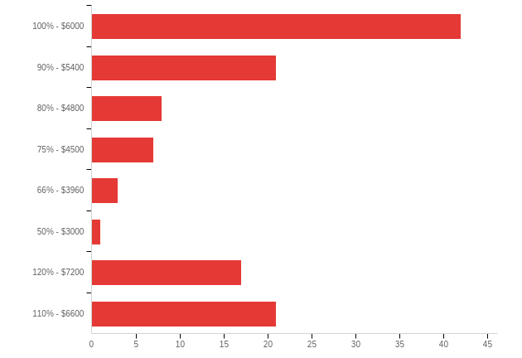

# | Answer | % | Count
1 | 100% - $6000 | 35.00% | 42
2 | 90% - $5400 | 17.50% | 21
3 | 80% - $4800 | 6.67% | 8
4 | 75% - $4500 | 5.83% | 7
5 | 66% - $3960 | 2.50% | 3
6 | 50% - $3000 | 0.83% | 1
7 | 120% - $7200 | 14.17% | 17
8 | 110% - $6600 | 17.50% | 21
 | Total | 100% | 120

Q27 - I would be able to take advantage of this opportunity without any additional support.
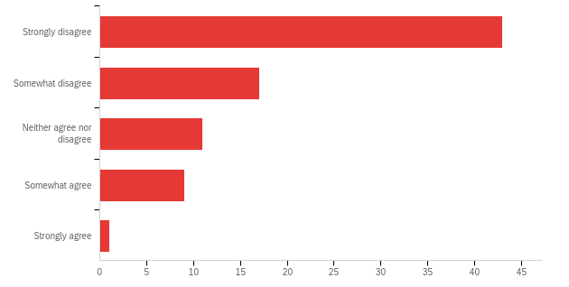

# | Field | Minimum | Maximum | Mean | Std Deviation | Variance | Count
1 | I would be able to take advantage of this opportunity without any additional support. | 1.00 | 5.00 | 1.86 | 1.10 | 1.20 | 81

# | Answer | % | Count
1 | Strongly disagree | 53.09% | 43
2 | Somewhat disagree | 20.99% | 17
3 | Neither agree nor disagree | 13.58% | 11
4 | Somewhat agree | 11.11% | 9
5 | Strongly agree | 1.23% | 1
 | Total | 100% | 81

Q28 - If you do not think you could take advantage of this opportunity, please indicate why:

# | Answer | % | Count
1 | I cannot afford to lose the income I would earn during that period. | 0.00% | 0
2 | I do not have access to housing if I am not an enrolled student. | 0.00% | 0
3 | I do not have funding to cover travel costs. | 0.00% | 0
 | Total |  | 0

Q29 - If you received a stipend in support of the internship, what percentage of $6000 would be enough for you to choose it rather than work?
In answering this question, please assume that this would be in the form of a direct payment to you. Assume that any support would include tax-free reimbursement for airfare. Please check all that apply.
The first two options are available should you believe you would need more than $6000 in order to take the internship.
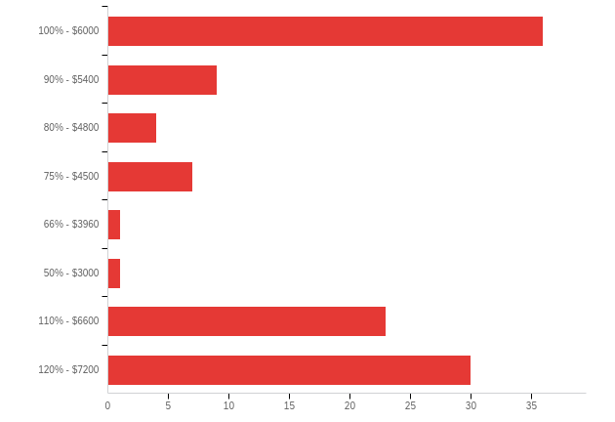

# | Answer | % | Count
1 | 100% - $6000 | 32.43% | 36
2 | 90% - $5400 | 8.11% | 9
3 | 80% - $4800 | 3.60% | 4
4 | 75% - $4500 | 6.31% | 7
5 | 66% - $3960 | 0.90% | 1
6 | 50% - $3000 | 0.90% | 1
7 | 110% - $6600 | 20.72% | 23
8 | 120% - $7200 | 27.03% | 30
 | Total | 100% | 111

Q24 - Are there any other barriers that you have faced while trying to navigate obtaining an internship?

Are there any other barriers that you have faced while trying to navigate obtaining an internship?
academic performance could be one of the reasons, but it mainly about the fanacial problem
N/A
Transportation
At first it was balancing the internship, school, and sports. So schedules and seasons were hard.
Transportation has been the biggest barrier while navigating an internship.
Transportation. Cost of living. Payment. Any other expenses required for an internship.
Yes, time management. I feel like with having to take 15+ units at UCD and being in clubs/greek life it is hard to manage an internship. I feel like if there was less homework and units to take and less pressure to be part of something in school then taking an internship would be easier.
I think the majority of it would be financial. I only have money from summer jobs, so it would definitely not last long enough. My parents might be able to help, but it's not a guarantee.
I have never looked for an internship, I plan to do so soon.
no
N/A
how much time it will take on a daily basis
Time periods
no
No
I have never had an internship
not really
Perhaps VISA concerns about whether non U.S citizens can work in unpaid internships.
I think the finical aspect of a internship is the most difficult for me because I need a way to earn income since my parents aren't supporting my college career
Something that I always have to consider are prior commitments (eg - existing job that sustains me throughout the school year) as well as payments for rent and other bills. Normally over the summer I try to work enough to make enough money that, should anything happen, I would have at least a few months rent covered / whatever additional payments I make in a month (eg - car payments)
I am unable to drive and do not have a car
Time constraints with school and my job, but if paid then my job would not be an issue
needing prior experience
Time constraints
Mostly financial aspects, or lack thereof.
just housing and payment

